Guide to booking examinations for September 2021
If you would like to pay for your exam booking by bank transfer please visit
https://www.actuaries.org.uk/studying/my-exams/book-your-exam to download and complete an Exam Entry form.
If you would like to pay for your exam booking by credit card, debit card or PayPal payment you can book your exam online.
Booking your exam online To book your exam online you need to log in to the My Account area of the IFoA website, using your ARN (Actuarial Reference Number) as a Username and your chosen Password.

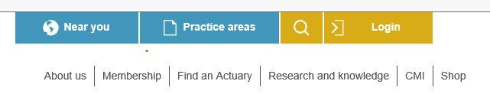

Once you have logged in select My Exams, Book an Exam and Book April/September exams, then select you examination session:
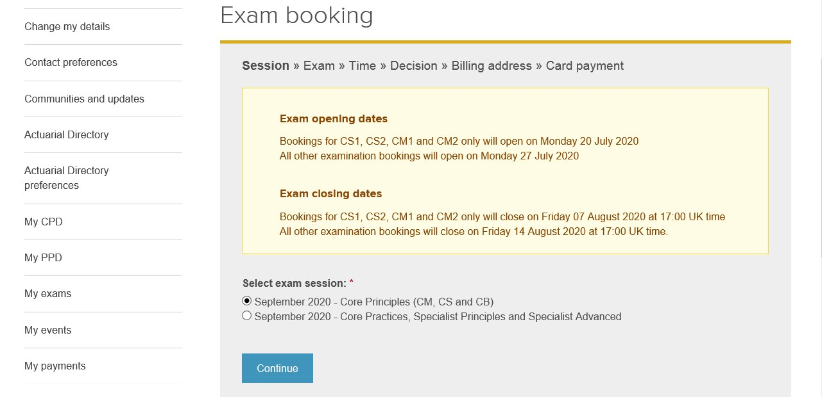

You will then be asked to select a subject. Please be aware you will only be allowed to choose one subject at a time.
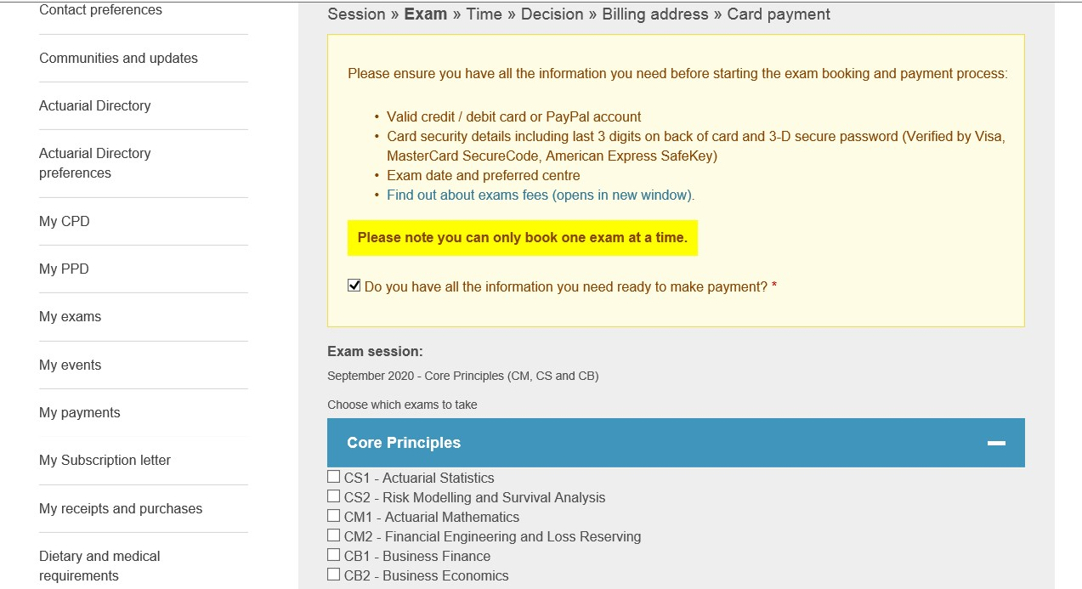

Select an examination time slot.
If you are booking more than one examination, please take care to avoid selecting multiple subjects which are sat on the same day.
You will only be able to sit one subject per day even if the start times are staggered.
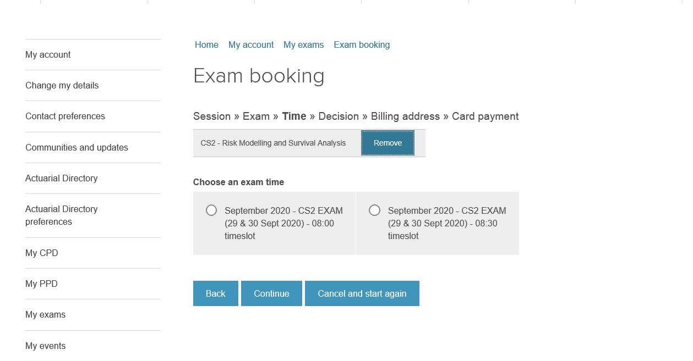
Once you have selected and confirmed your exam slot, you will be asked to make payment.
After you have made a successful payment you will receive an email confirming your booking.
If you wish to book another examination please select Book an exam in the My Account area of the IFoA website and repeat the process.

Time slots for September 2021 Examinations
The table below shows the time slots available for each examination in our September 2021 session. There are limited numbers of places available for each time slot, so once a particular one is full we will be unable to take any more bookings.
Examination | Time slots available (all slots are UK time) | Notes
CM1 | 08:00 | The time slot booked applies to both papers i.e. if you book 08:00 then you will sit both  A and B papers at 08:00 | A paper 13 September
 | 08:30 |  | B paper 14 September
 | 09:00
CM2 | 08:00 | The time slot booked applies to both papers i.e. if you book 08:00 then you will sit both A and B papers at 08:00 | A paper 27 September
 | 08:30 |  | B paper 28 September
CS1 | 08:00 | The time slot booked applies to both papers i.e. if you book 08:00 then you will sit both A and B papers at 08:00 | A paper 17 September
 | 08:30 |  | B paper 20 September
CS2 | 08:00 | The time slot booked applies to both papers i.e. if you book 08:00 then you will sit both A and B papers at 08:00 | A paper 22 September
 | 08:30 |  | B paper 23 September
CB1 | 08:00 |  | 24 September
 | 08:30
CB2 | 09:30 |  | 15 September
 | 10:00
CP1 | 09:00 | The time slot booked applies to both papers i.e. if you book 09:00 then you will sit both papers at 09:00 | Paper 1 17 September
 | 09:30 |  | Paper 2 20 September
CP2 | 09:30 | The time slot booked applies to both papers i.e. if you book 09:00 then you will sit both papers at 09:00 | Paper 1 13 September
 | 10:00 |  | Paper 2 14 September
CP3 | 08:00 |  | 15 September
 | 08:30
 | 09:00
SP1 | 09:00 | This is the only time slot available for this examination | 27 September
SP2 | 09:00 | This is the only time slot available for this examination | 22 September
SP4 | 09:30 | This is the only time slot available for this examination | 22 September
SP5 | 09:30 | This is the only time slot available for this examination | 27 September
SP6 | 10:00 | This is the only time slot available for this examination | 22 September
SP7 | 10:00 | This is the only time slot available for this examination | 27 September
SP8 | 09:00 | This is the only time slot available for this examination | 28 September
SP9 09:30 This is the only time slot available for this 28 September examination
SA1 | 09:00 | This is the only time slot available for this examination | 23 September
SA2 | 09:15 | This is the only time slot available for this examination | 23 September
SA3 | 09:30 | This is the only time slot available for this examination | 23 September
SA4 | 09:45 | This is the only time slot available for this examination | 23 September
SA7 | 10:00 | This is the only time slot available for this examination | 23 September

If you have any questions or issues during the booking process please contact memberservices@actuaries.org.uk and we will do our best to assist you.

